training 1 epoch...

971.5456266403198 seconds used......

1 training finished! average train loss: 0.677294418302171

evaluating...

Confusion matrix, without normalization

[[ 664 158 124]

[ 868 4169 167]

[1279 378 5789]]

Normalized confusion matrix

[[0.70190275 0.16701903 0.13107822]

[0.16679477 0.80111453 0.0320907 ]

[0.17177008 0.05076551 0.77746441]]

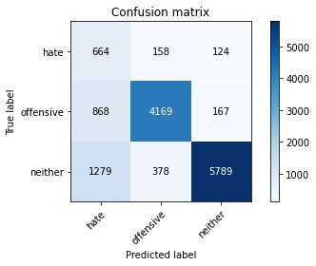

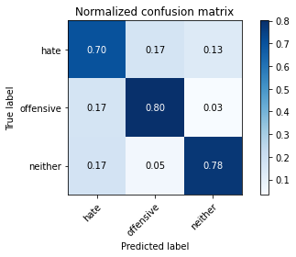

precision recall f1-score support

hate 0.24 0.70 0.35 946

offensive 0.89 0.80 0.84 5204

neither 0.95 0.78 0.86 7446

accuracy 0.78 13596

macro avg 0.69 0.76 0.68 13596

weighted avg 0.88 0.78 0.82 13596

average eval_loss: 0.5181069223319783, accuracy: 0.7812591938805531

training 2 epoch...

970.9471123218536 seconds used......

2 training finished! average train loss: 0.5371333483325714

evaluating...

Confusion matrix, without normalization

[[ 612 195 139]

[ 589 4410 205]

[1031 311 6104]]

Normalized confusion matrix

[[0.64693446 0.20613108 0.14693446]

[0.11318217 0.84742506 0.03939277]

[0.1384636 0.04176739 0.819769 ]]

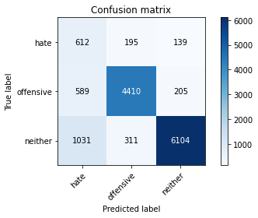

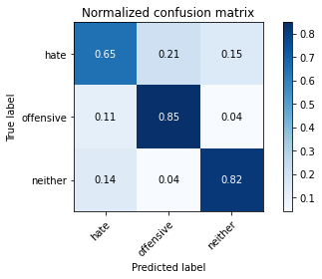

precision recall f1-score support

hate 0.27 0.65 0.39 946

offensive 0.90 0.85 0.87 5204

neither 0.95 0.82 0.88 7446

accuracy 0.82 13596

macro avg 0.71 0.77 0.71 13596

weighted avg 0.88 0.82 0.84 13596

average eval_loss: 0.46572276240981675, accuracy: 0.8183289202706678

training 3 epoch...

970.852373123169 seconds used......

3 training finished! average train loss: 0.4420824896825081

evaluating...

Confusion matrix, without normalization

[[ 597 157 192]

[ 771 4195 238]

[ 767 366 6313]]

Normalized confusion matrix

[[0.63107822 0.16596195 0.20295983]

[0.14815527 0.80611068 0.04573405]

[0.10300833 0.04915391 0.84783777]]

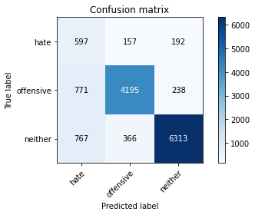

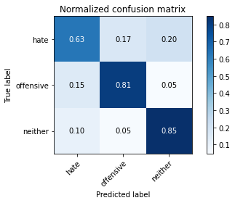

precision recall f1-score support

hate 0.28 0.63 0.39 946

offensive 0.89 0.81 0.85 5204

neither 0.94 0.85 0.89 7446

accuracy 0.82 13596

macro avg 0.70 0.76 0.71 13596

weighted avg 0.87 0.82 0.84 13596

average eval_loss: 0.46926899929257, accuracy: 0.8167843483377464

Confusion matrix, without normalization

[[1413 186 236]

[1272 4345 308]

[2626 429 7699]]

Normalized confusion matrix

[[0.77002725 0.1013624 0.12861035]

[0.21468354 0.73333333 0.05198312]

[0.24418821 0.03989213 0.71591966]]

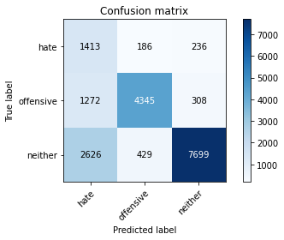

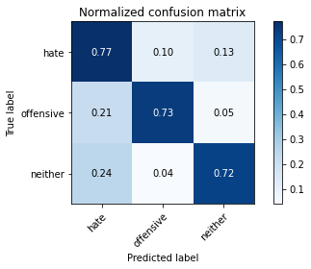

precision recall f1-score support

hate 0.27 0.77 0.40 1835

offensive 0.88 0.73 0.80 5925

neither 0.93 0.72 0.81 10754

accuracy 0.73 18514

macro avg 0.69 0.74 0.67 18514

weighted avg 0.85 0.73 0.77 18514

average eval_loss: 0.624933918837466, accuracy: 0.7268553527060603

[19]:

0.7268553527060603